**Pom.xml**

**<dependency>**

**<groupId>junit</groupId>**

**<artifactId>junit</artifactId>**

**<version>3.8.1</version>**

**<scope>test</scope>**

**</dependency>**

**<dependency>**

**<groupId>org.springframework</groupId>**

**<artifactId>spring-core</artifactId>**

**<version>5.2.2.RELEASE</version>**

**</dependency>**

**<!-- https://mvnrepository.com/artifact/org.springframework/spring-context -->**

**<dependency>**

**<groupId>org.springframework</groupId>**

**<artifactId>spring-context</artifactId>**

**<version>5.2.2.RELEASE</version>**

**</dependency>**

**Bike.java**

**//source->generate-> 4 methods**

**package sybca.JUNIT_TEST;**

**public class Bike {**

**private String name;**

**private int year;**

**public String getName() {**

**return name;**

**}**

**public void setName(String name) {**

**this.name = name;**

**}**

**public int getYear() {**

**return year;**

**}**

**public void setYear(int year) {**

**this.year = year;**

**}**

**public Bike() {**

**super();**

**// TODO Auto-generated constructor stub**

**}**

**public Bike(String name, int year) {**

**super();**

**this.name = name;**

**this.year = year;**

**}**

**@Override**

**public String toString() {**

**return "Bike [name=" + name + ", year=" + year + "]";**

**}**

**}**

**Config.xml**

**<?xml version="1.0" encoding="UTF-8"?>**

**<beans xmlns="http://www.springframework.org/schema/beans"**

**xmlns:xsi="http://www.w3.org/2001/XMLSchema-instance" xmlns:context="http://www.springframework.org/schema/context"**

**xmlns:p="http://www.springframework.org/schema/p"**

**xsi:schemaLocation="http://www.springframework.org/schema/beans**

**http://www.springframework.org/schema/beans/spring-beans.xsd**

**http://www.springframework.org/schema/context**

**http://www.springframework.org/schema/context/spring-context.xsd">**

**<bean class="sybca.JUNIT_TEST.Bike" name="bike1" >**

**<property name="name" value="Java"/>**

**<property name="year" value="2010"/>**

**</bean>**

**</beans>**

**App.java**

**package sybca.JUNIT_TEST;**

**import org.springframework.context.ApplicationContext;**

**import org.springframework.context.support.ClassPathXmlApplicationContext;**

**/\*\***

**\* Hello world!**

**\***

**\*/**

**public class App**

**{**

**public static void main( String[] args )**

**{**

**ApplicationContext context=new ClassPathXmlApplicationContext("sybca/JUNIT_TEST/config.xml");**

**Bike b1=(Bike) context.getBean("bike1");**

**System.*out*.println(b1);**

**}**

**}**

**Add Junit test case**

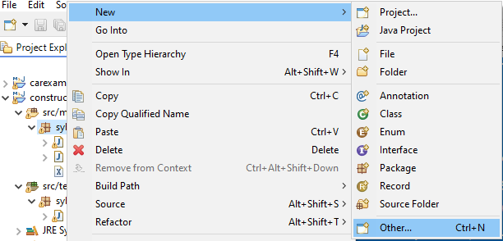

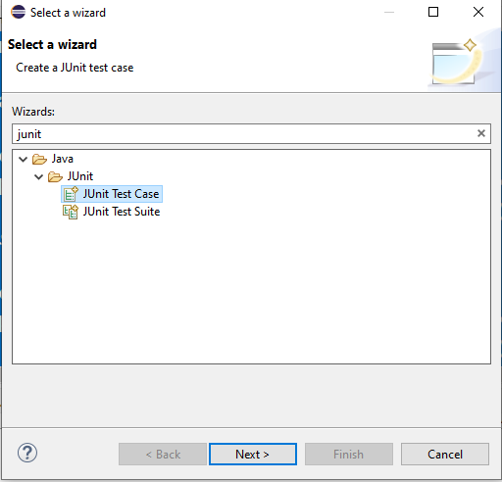

**Create new Testcase**

**And enter class under test as Bike-> Click Next**

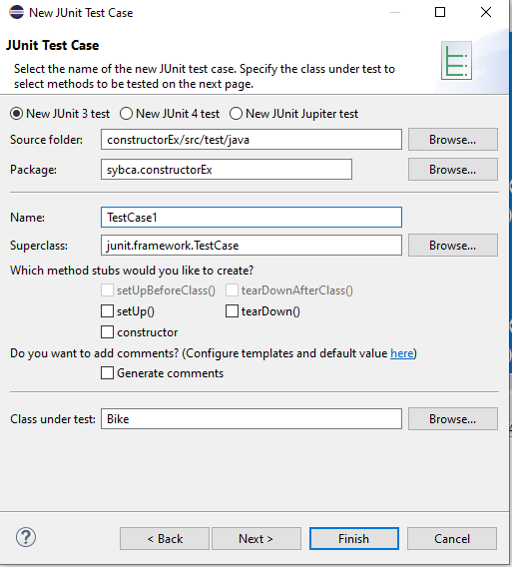

**Select the methods for testing**

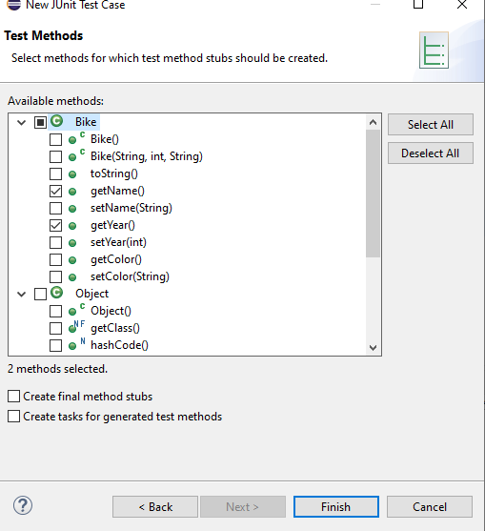

**Click Finish**

**package** sybca.constructorEx;

**import** org.springframework.context.ApplicationContext;

**import** org.springframework.context.support.ClassPathXmlApplicationContext;

**import** junit.framework.TestCase;

**public** **class** sybcatest1 **extends** TestCase {

**public** **void** testGetYear() {

ApplicationContext context=**new** ClassPathXmlApplicationContext("sybca/constructorEx/config.xml");

Bike b1=(Bike) context.getBean("bike1");

*assertEquals*(2010, b1.getYear());

}

**public** **void** testName() {

ApplicationContext context=**new** ClassPathXmlApplicationContext("sybca/constructorEx/config.xml");

Bike b1=(Bike) context.getBean("bike1");

*assertEquals*("Java", b1.getName());

}

}